Margin Requirements
- For margin trading of securities, initial margin is the percentage of the purchase price of the securities that the investor must have in their account.
- Maintenance margin is the minimum amount of equity that must be maintained in a margin account.

- At IB, for Reg T margin purchases, you generally are required to have a minimum of 50% of the purchase price of the securities in the account by the end of trading on the day of the purchase. This amount is set by the Fed within Regulation T. However brokers may have greater in-house requirements.

- In accordance with US regulations, the minimum maintenance margin requirement for a long stock position is 25% of the value of the shares.

- Long Market Value – The current market price of all positions in the account
- Short Market Value – The current market value of the positions that have been sold short
- Debit Balance – The amount the customer has borrowed and owes the brokerage firm
- Credit Balance – The cash on deposit in the account

- Equity – The investor’s ownership interest in the account
- Excess Equity – The amount of equity in the account that exceeds the maintenance margin requirements
- SMA – Special Memorandum Account, a line of credit that is established by the broker dealer in accordance with Reg T.
- Buying power – This is based on your SMA and reflects an account’s ability to purchase additional investment products.

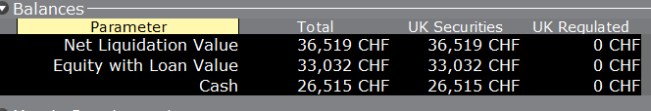
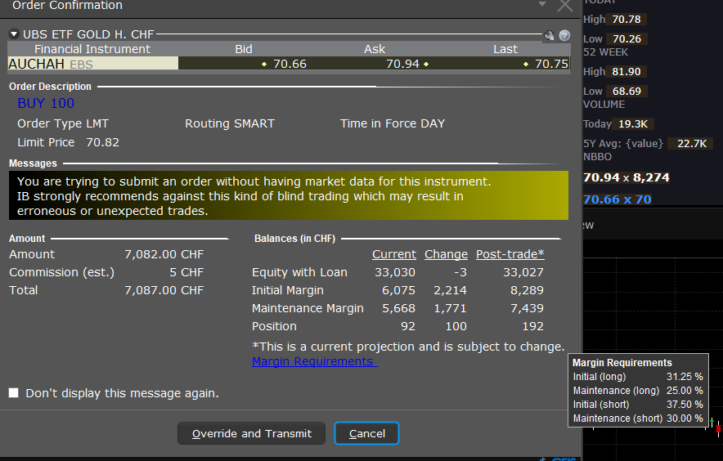
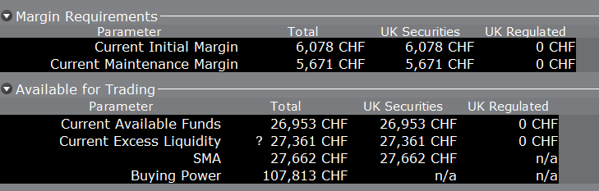
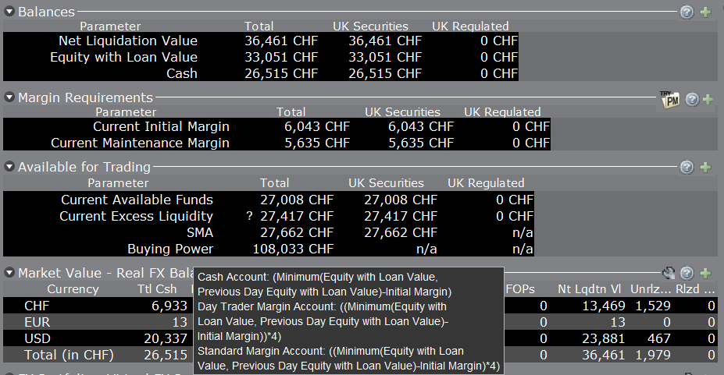
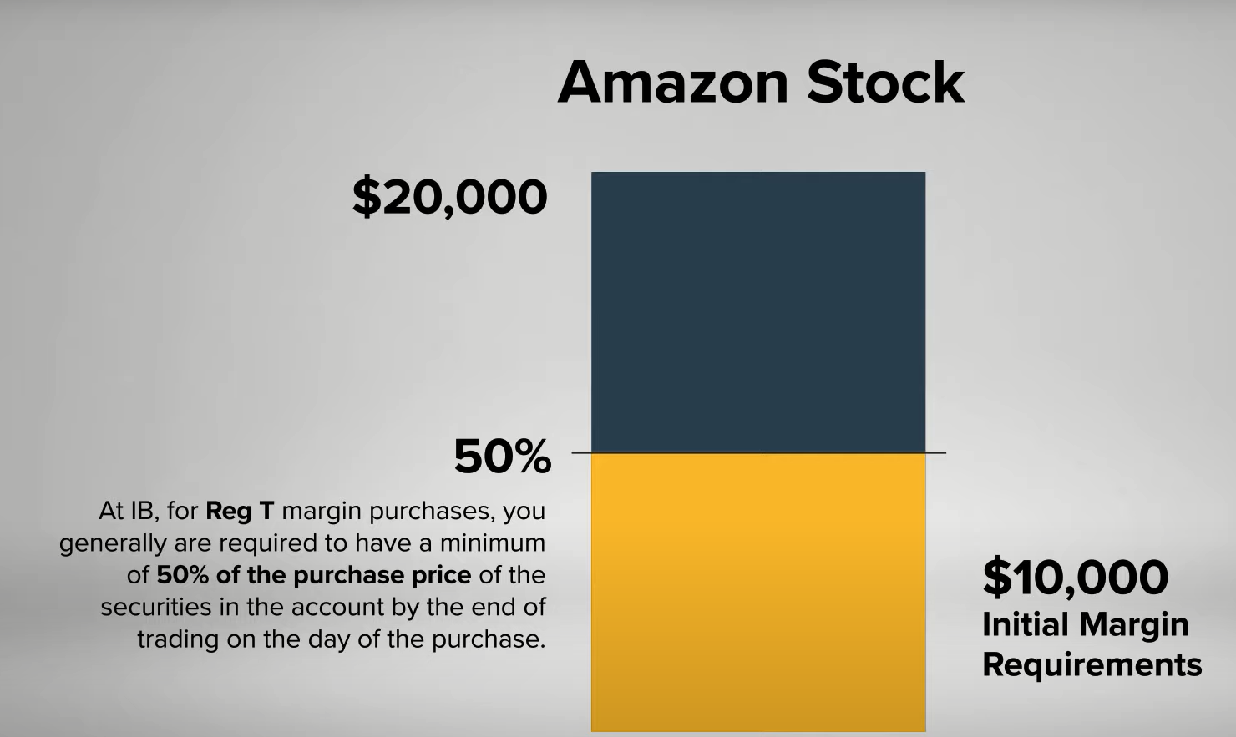

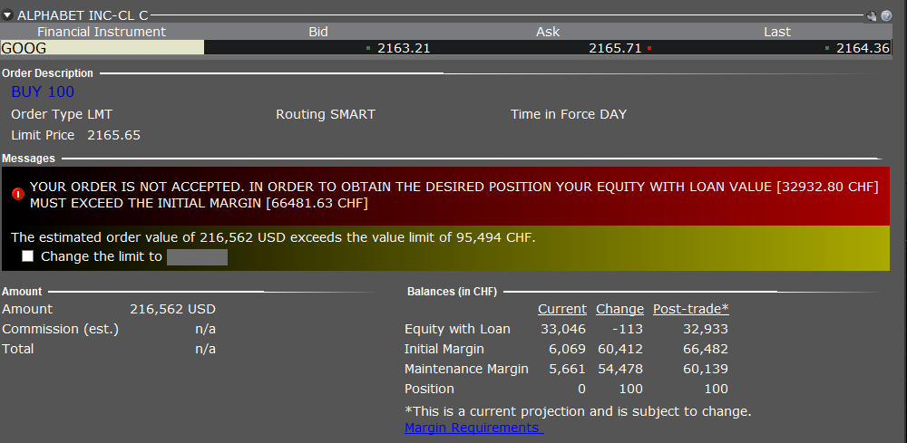
- For margin trading of securities, initial margin is the percentage of the purchase price of the securities that the investor must have in their account.
- Maintenance margin is the minimum amount of equity that must be maintained in a margin account.

